Tutorial – 6

- Design an application like follow. Depends on user selection it will display the message as shown. (If gender is Male then Mr. or Female then Miss)

using System;
using System.Collections.Generic;
using System.ComponentModel;
using System.Data;
using System.Drawing;
using System.Linq;
using System.Text;
using System.Threading.Tasks;
using System.Windows.Forms;
using System.Xml.Linq;

namespace Turorial_6
{
public partial class Form1 : Form
{
public Form1()
{
InitializeComponent();
}

private void button1_Click(object sender, EventArgs e)
{
string name = textBox1.Text.Trim();
string prefix = "";

// Gender Selection
if (radioButton1.Checked)
{
prefix = "Mr.";
}
else if (radioButton2.Checked)
{
prefix = "Miss";
}

// Sources of Information

List<string> sources = new List<string>();
if (checkBox1.Checked) sources.Add("News Paper");
if (checkBox2.Checked) sources.Add("Friends");
if (checkBox3.Checked) sources.Add("Website");
if (checkBox4.Checked && !string.IsNullOrWhiteSpace(textBox2.Text))
sources.Add(textBox2.Text);

// Final Output
string sourceText = string.Join(", ", sources);
lblMessage.Text = $"Hello {prefix} {name}. You know about us from {sourceText}.";
}
}
}

Output:
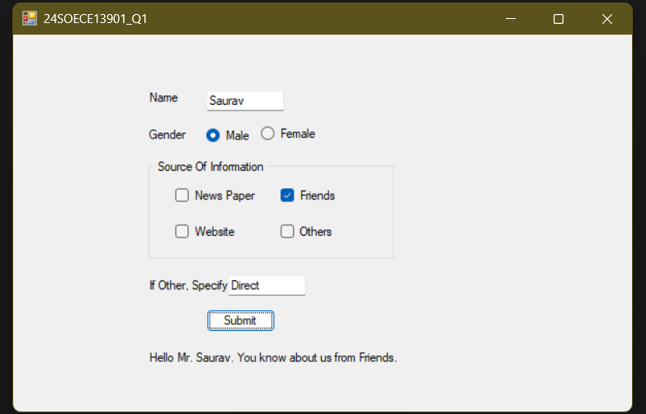

- Design a form like below. Implement Following functionality to the application.

using System;
using System.Collections.Generic;
using System.ComponentModel;
using System.Data;
using System.Drawing;
using System.Linq;
using System.Text;
using System.Threading.Tasks;
using System.Windows.Forms;
using System.Xml.Linq;

namespace Turorial_6
{
public partial class Form2 : Form
{
public Form2()
{
InitializeComponent();
}

private void btnFill_Click(object sender, EventArgs e)
{
listBox1.Items.Add("Saurav");
listBox1.Items.Add("Razz");
listBox1.Items.Add("Rajan");
listBox1.Items.Add("Rahul");
listBox1.Items.Add("Mohin");
}

private void btnSort_Click(object sender, EventArgs e)
{
listBox1.Sorted = true;
}

private void btnClear_Click(object sender, EventArgs e)
{
listBox1.Items.Clear();
lblCount.Text = "Total Items: 0";
lblSelection.Text = "Your Selection: ";

}

private void btnRemove_Click(object sender, EventArgs e)
{
if (listBox1.SelectedItem != null)
{
listBox1.Items.Remove(listBox1.SelectedItem);
}
else
{
MessageBox.Show("Please select an item to remove.");
}
}

private void btnCount_Click(object sender, EventArgs e)
{
int total = listBox1.Items.Count;
lblCount.Text = "Total Items: " + total;
}

private void listBox1_SelectedIndexChanged(object sender, EventArgs e)
{
if (listBox1.SelectedItem != null)
{
lblSelection.Text = "Your Selection: " + listBox1.SelectedItem.ToString();
}
}
}
}

Output :
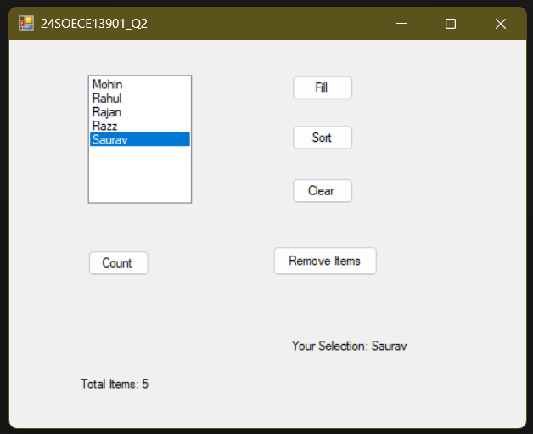

- Design an application which has three textboxes. Implement restricted policy for each
textbox to enter data only in numeric form, uppercase, characters.

using System;
using System.Collections.Generic;
using System.ComponentModel;
using System.Data;
using System.Drawing;
using System.Linq;
using System.Text;
using System.Threading.Tasks;
using System.Windows.Forms;

namespace Turorial_6
{
public partial class Form3 : Form

{
public Form3()
{
InitializeComponent();
}
private void txtNumeric_KeyPress(object sender, KeyPressEventArgs e)
{
if (!char.IsControl(e.KeyChar) && !char.IsDigit(e.KeyChar))
{
e.Handled = true;
}
}

private void txtUpper_KeyPress(object sender, KeyPressEventArgs e)
{
// Convert to uppercase automatically
e.KeyChar = char.ToUpper(e.KeyChar);

// Allow only letters, backspace
if (!char.IsControl(e.KeyChar) && !char.IsLetter(e.KeyChar))
{
e.Handled = true;
}
}
private void txtChars_KeyPress(object sender, KeyPressEventArgs e)
{
// Allow only letters, backspace, space
if (!char.IsControl(e.KeyChar) && !char.IsLetter(e.KeyChar) && e.KeyChar != ' ')
{
e.Handled = true;
}
}
}
}

Output :
